**Free living nematodes, *C. elegans***

Caenorhabditis elegans is a small, free-living soil nematode (roundworm). There are two C. elegans sexes: a self-fertilizing hermaphrodite (XX) and a male (XO). Males arise infrequently (0.1%). Mutant animals are readily obtained by chemical mutagenesis or exposure to ionizing radiation. The strains can be kept as frozen stocks for long periods of time. C. elegans can also endure harsh environmental conditions by switching to a facultative diapause stage called the dauer larva, which can survive four to eight times the normal 3-week life span

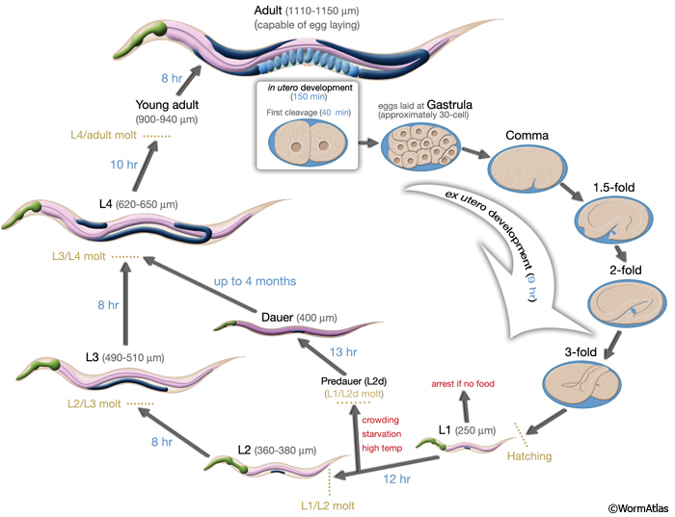

**Behavior**

**Exercise 1: Observe and film C. elegans as it moves in media.** Adults are 1 mm or less in length and exhibit the shape typical of nematodes, being cylindrical in cross-section and tapered at both ends. The anterior end, however is blunter than the acutely pointed posterior end and the two are easily distinguished.

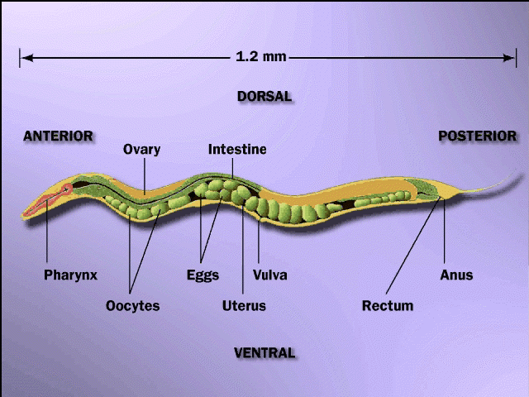

**1b. Anatomy:**

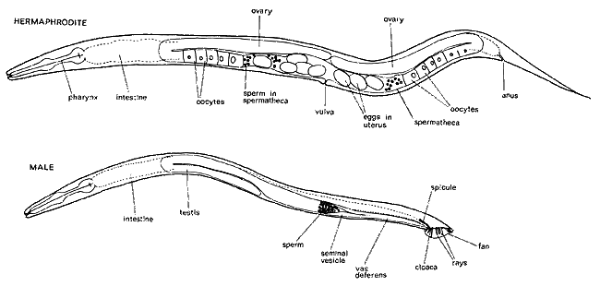 Examine the preparation with the stereoscope under highest power

Choose the largest specimens you can find for observation.. You will probably not be able to find males. Males also have a pair of copulatory spicules sprotruding from the cloaca near the posterior end of the worm.

Most of the specimens you can find are females. Females, being viviparous, usually contain juvenile worms of various sizes. Study representatives of both sexes. 1b. Take a photograph of your nematode preparation. Identify if you can your worms as male or female if you can. Identify as many of the internal organs as you can.

ROTIFERS

The anterior end of the animal has one or more ciliated bands, the **corona,** involved in suspension feeding and locomotion. Not all rotifers have a corona.

A neck connects the corona to the trunk, the latter holding most of the organ systems.. The mouth is set in the midst of the corona, and opens into the pharynx, which includes a highly specialized set of internal jaw-like elements collectively called a **mastax.** The mastax is clearly visible in most larger rotifers as a cuticularized mass in the neck region, it tends to move periodically by muscles attached to it. The mastax is a complex, cuticularized region of the pharynx, with several jaw elements (called **trophi),** operated by specialized musculature. You should be able to see the trophi at high magnification. The structure of trophi vary greatly among rotifer groups and is related to feeding mode, some are used for grinding food captured by suspension feeding (such as diatoms), others are raptorial and serve carnivorous species, yet others are suctorial, creating a piston-like action.

The **stomach** is the most conspicuous feature at mid body, and it is comprised of unusually large cells. Females have a syncytial ovary and yolk gland in one. Most rotifer populations are all female but males can be produced seasonally in some. All these organs lie in a spacious **pseudocoel.** Many rotifers also have an annulated posterior foot, often ending in a pair of toes. Cement glands running down the foot serve to attach these animals through their opening on the toes. In the pond water/culture you will be observing planktonic rotifers, which swim around with their corona

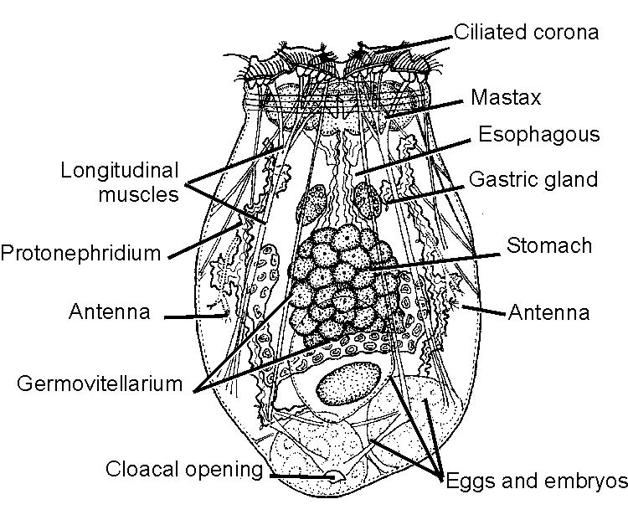

**Exercise two: a. Film rotifer locomotion. b. Describe how they use their “toes” or “feet”? c. Obtain a movie of their feeding. If you cannot observe them feed take a photograph of a living specimen and label the corona, mastax and stomach.**

GASTROTRICHA

Gastrotrichs are a small phylum of minute, ciliated, acoelomate worms. The group includes both marine and freshwater species. *Lepidodermella* is a small freshwater species that lives on algae and debris in ponds. Study the animals provided under high magnification; you may want to use protoslo, or draw water out with a paper towel used as a wick from under the slide, to slow them down.

Note the rounded head, with **bristle clumped in tufts**, followed by a narrowed "neck", elongate trunk, and the paired caudal **furci** that end in the adhesive organs.

Gastrotrichs are covered with **cuticle,** yet are partly ciliated – each cilia itself has a thin cuticular covering. The cuticle in many gastrotrichs can be ornamented with scales and spines. Watch the animal move with cilia (in two ventral tracts in this species) and attach with the adhesive system.

Note the terminal mouth, leading to a **buccal capsule**, muscular and elongate **pharynx,** and **simple mid gut.**.

Many freshwater gastrotrichs reproduce first parthenogenically, then become hermaphroditic and reproduce sexually later in life. The affinities of gastrotrichs to other phyla are much debated and remain uncertain.

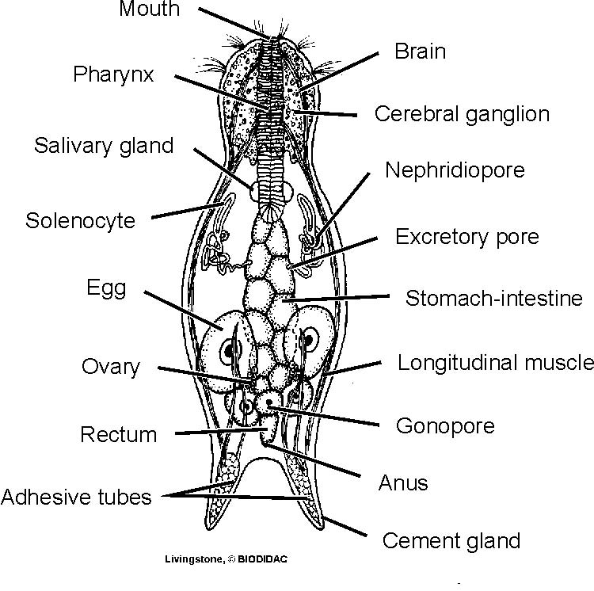

**Exercise 3: Obtain a movie of gastrotrich locomotion and compare it to that of a rotifer. Although you do not have to record anything in your journal, it will help you review for the final if you take some time to compare gastrotrich and rotifer phylogeny.**

Tardigrada

Tardigrades are all aquatic and found in both freshwater and marine environments. The **chitinous cuticle** covering a tardigrade's body has an outer epicuticle, formed of cross-linked proteins; middle intracuticle containing lipid; and inner procuticle, a mixture of chitin and proteins. Like arthropods the coelom is reduced and the **haemocoel** is the dominant body cavity. The cuticle is not waterproofed. Tardigrades are capable of withstanding adverse conditions by cryptobiosis. The dormant forms, called **tuns**, can survive temperatures from -272 degrees C to 151 degrees C, live for over 100 years, and survive radiation levels 1,000 times what humans can handle.

Tardigrades are so small you will probably only be able to view the external animal. Do observe locomotion in this organism tat lack jointed appendages.

Cephalization in these animals is weak, and there are no appendages like those found in other panarthropods. They may have been lost as these unique little animals adapted to their miniature world. The **mouth** is located at the anterior tip of the animals. The **stylets** of the feeding apparatus may be visible through the transparent cuticle. Tardigrades feed by piercing their food and sucking the fluids out using the muscular pharynx.

The trunk consists of four segments covered with sculpted **cuticular plates**. Four pairs of fleshy lobe-like **legs** include three that extend from the sides of the tardigrade and the posterior most pair extending behind. The lobe-like legs are extended by hydrostatic pressure and retracted by **bands of muscle** that extend to the tip of each leg. The legs terminate in a pair of **claws**, or in some species, an adhesive pad.

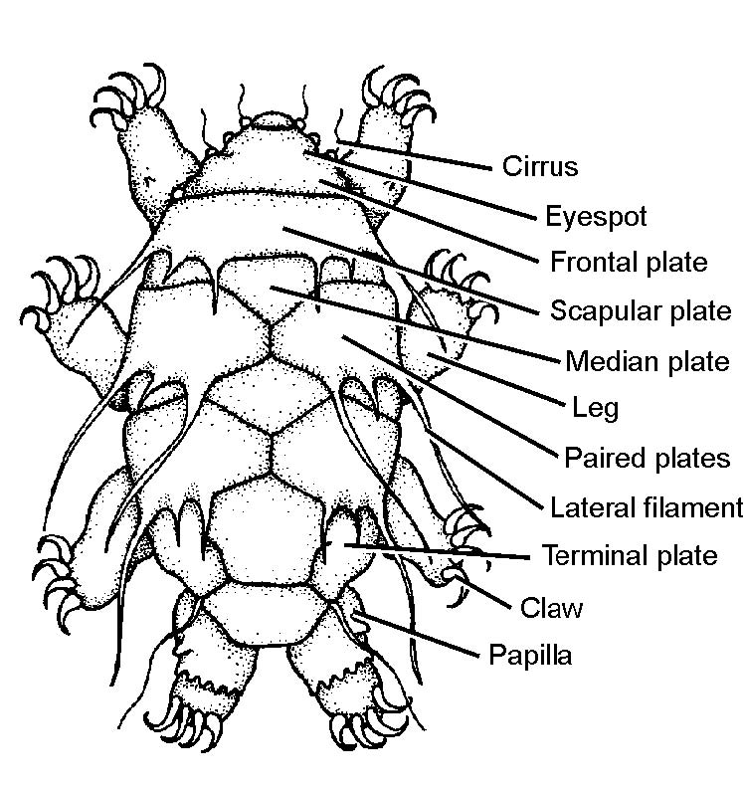

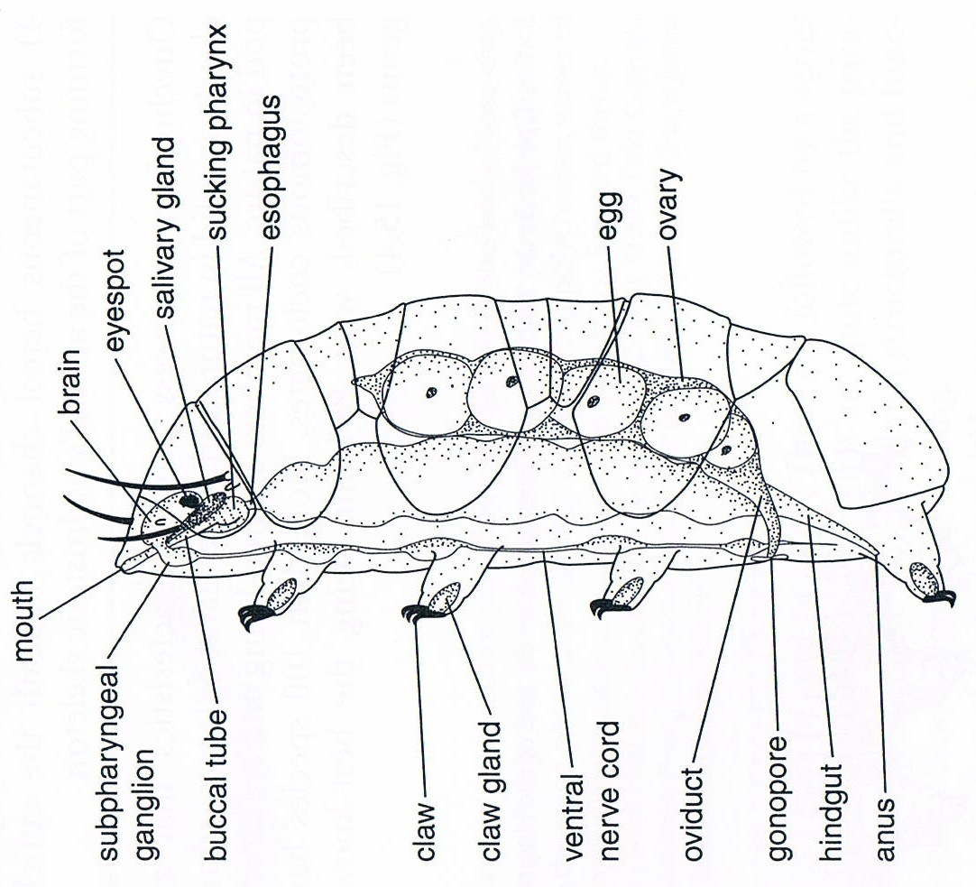

**Exercise 6: Obtain movies of tardigrade movement and feeding if possible. If you do not see them feed than try to get a high resolution photograph of an individual and label whatever structures you can see.**